Authentication and Authorization in ASP.NET Core Web API Microservices

Question 1: Implement JWT Authentication in ASP.NET Core Web API
Generated a JWT token upon successful login.
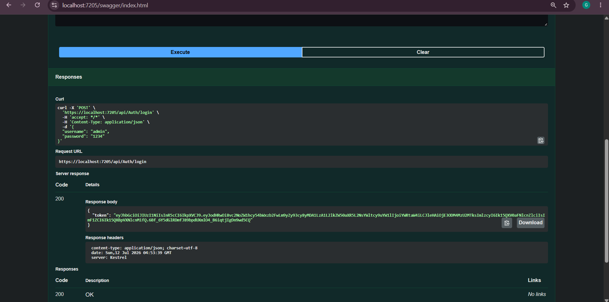

Generated Token using Scalar
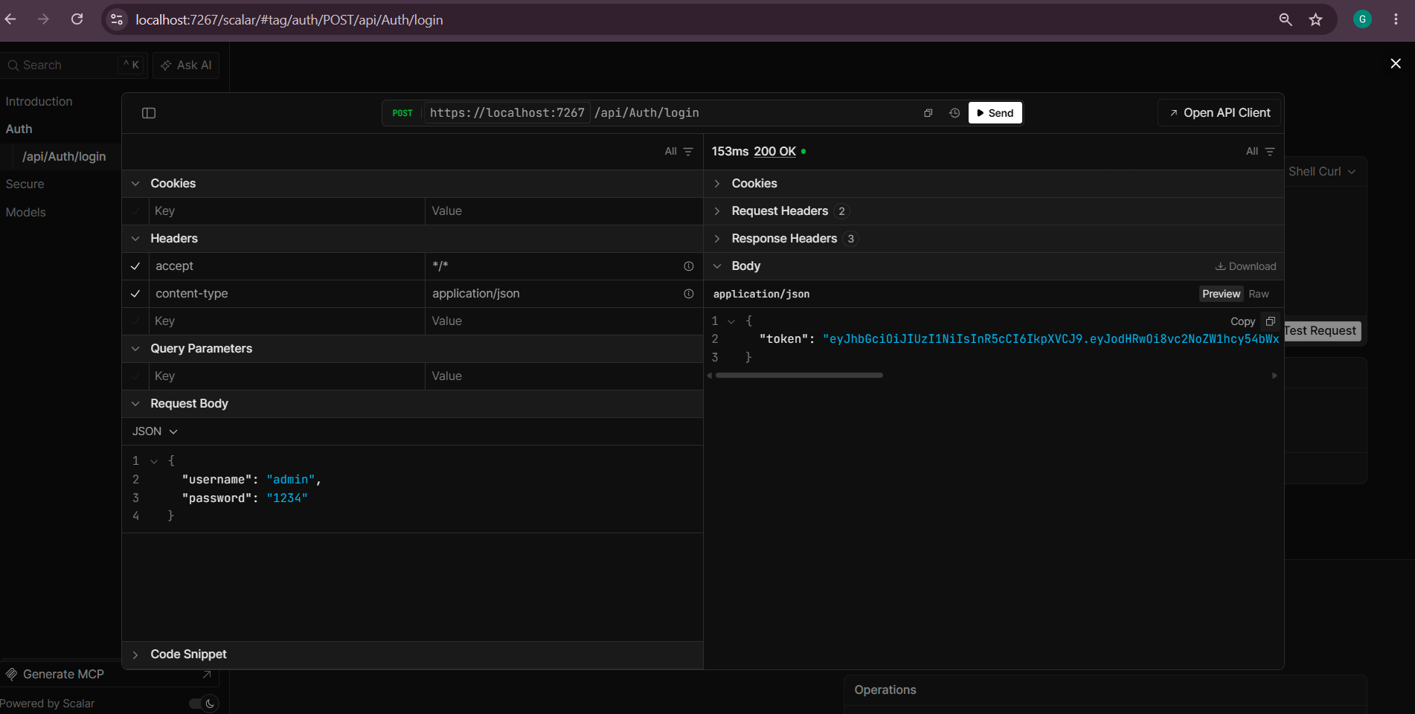
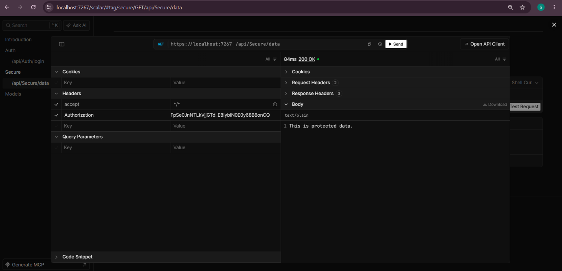
Secure an API Endpoint Using JWT

